Evidence for Project Unit

Ross Hill

Cohort E18

**P1 – Contributors Page**

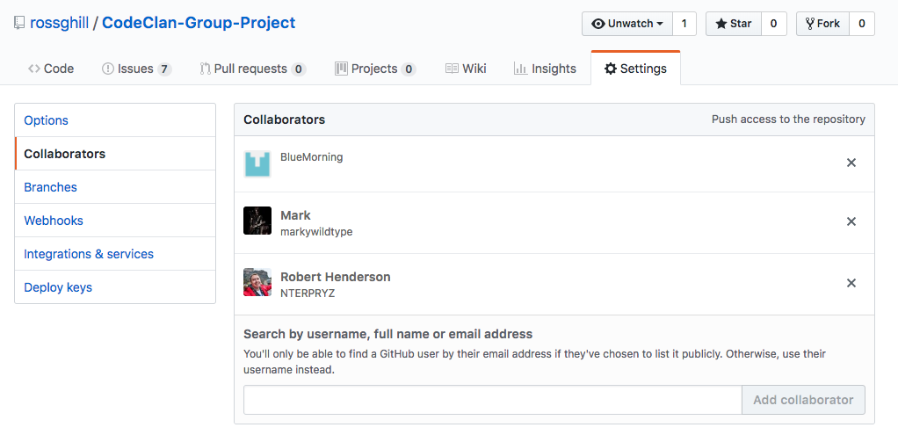

**P2 – Project Brief**

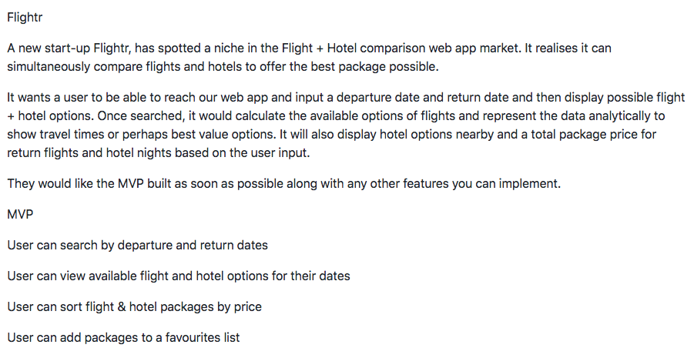

**P3 – Project Planning**

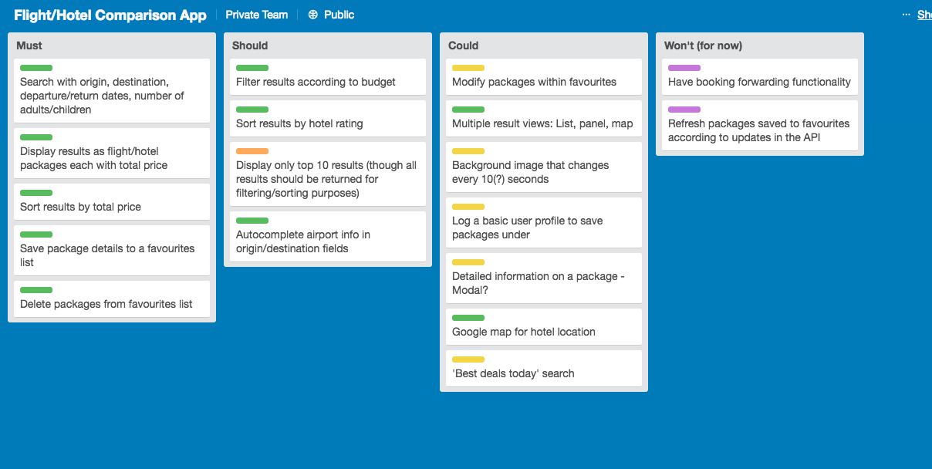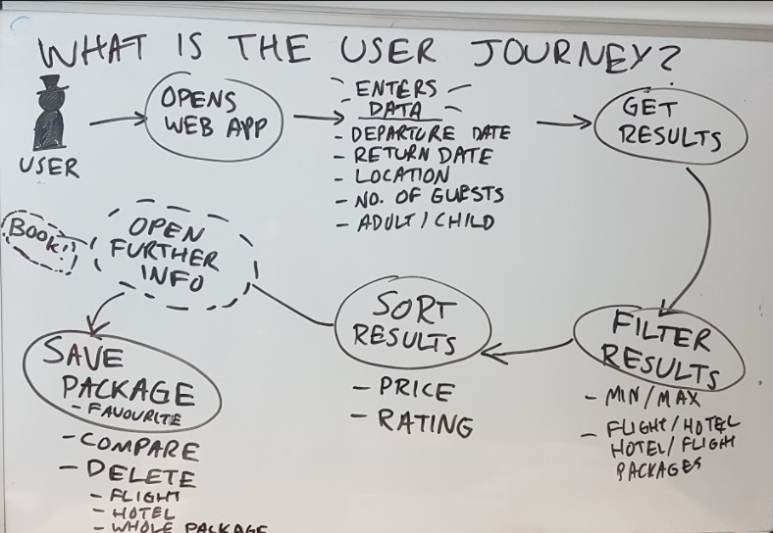

**P4 – Acceptance criteria/ Test Plan**

|  |  |  |
| --- | --- | --- |
| Acceptance Criteria | Expected Result/Output | Pass/Fail |
| A user is able to view all animals available for adoption | List of all available pets are displayed when link is clicked | **Pass** |
| A staff member is able to view all pets assigned to owners | Pets are sorted into list with ‘available to adopt’ status on performing search | **Pass** |
| A staff member is able to assign an animal to a new owner | When staff member inputs a new owner for an animal this change is reflected on the main page | **Pass** |
| A staff member is able to remove pets from the database | Upon clicking the remove button, the animal is removed from the displayed list | **Pass** |

**P5 – User sitemap**

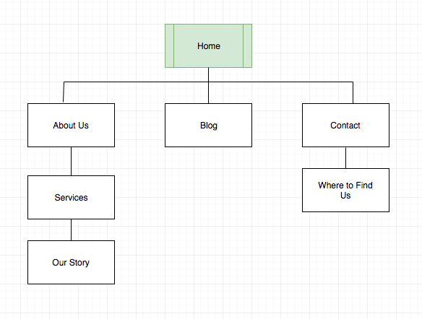

**P6 – Wireframe designs**

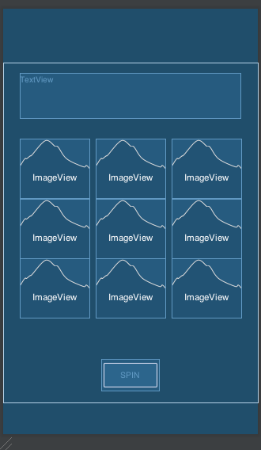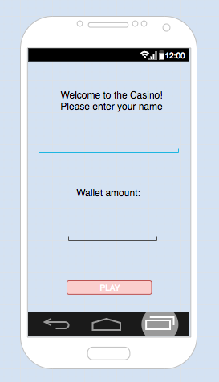

**P7 – System interaction diagrams**

**P8 – Object diagrams**

**P9 – Algorithms**

**P10 – Pseudocode**

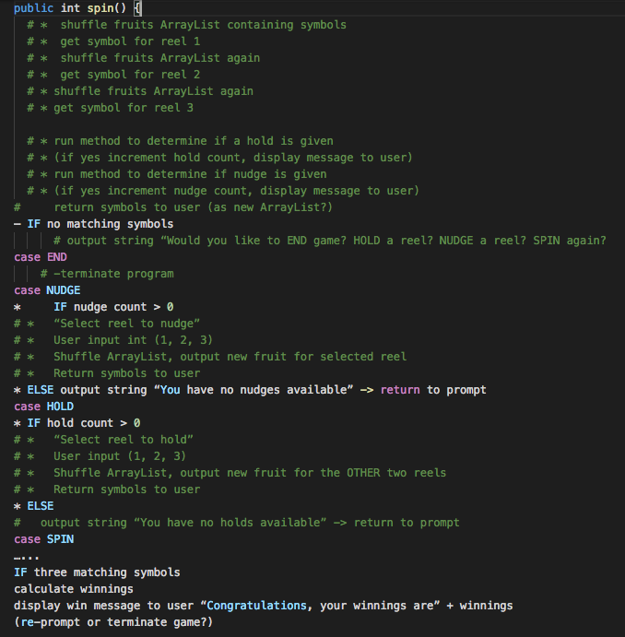

**P11 – Solo Project**

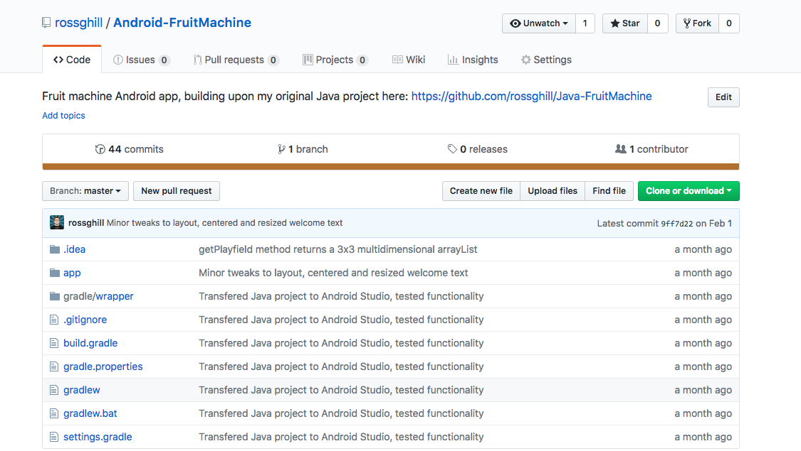

**https://github.com/rossghill/Android-FruitMachine**

**P12 – Planning and Development**

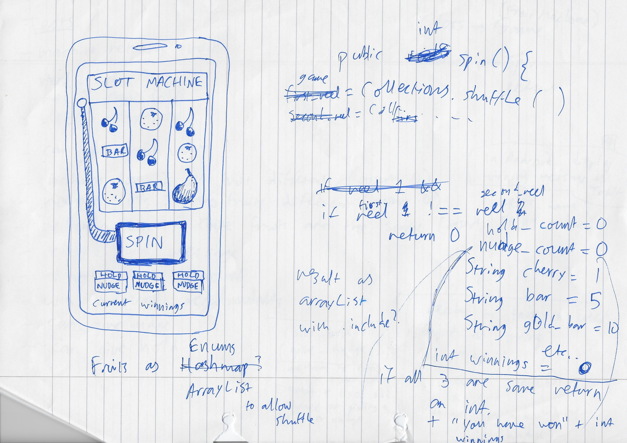

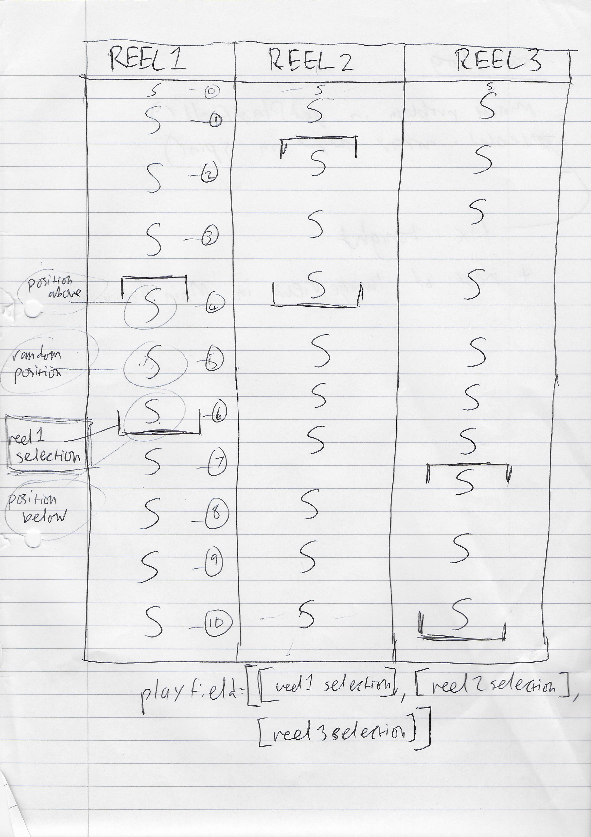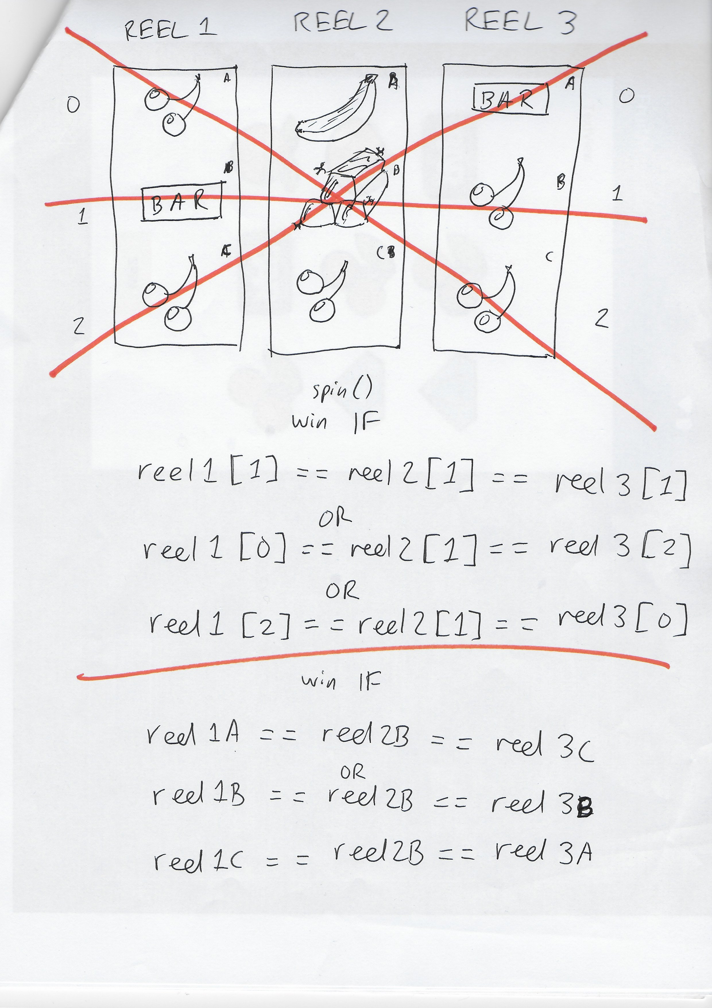

**P13 – User input**

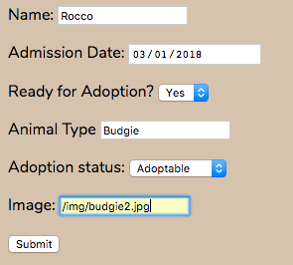

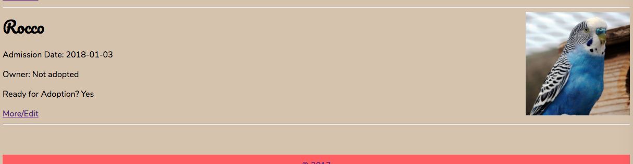

**P14/ P15 – Data persistence/ Results and feedback**

Initial state:

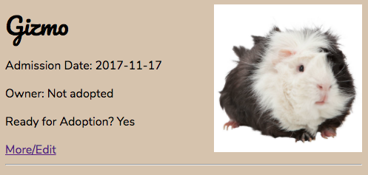

Request:

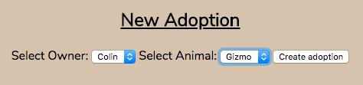

Result:

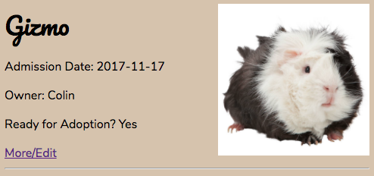

**P16 – API use**

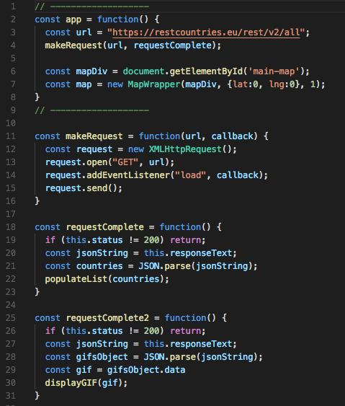

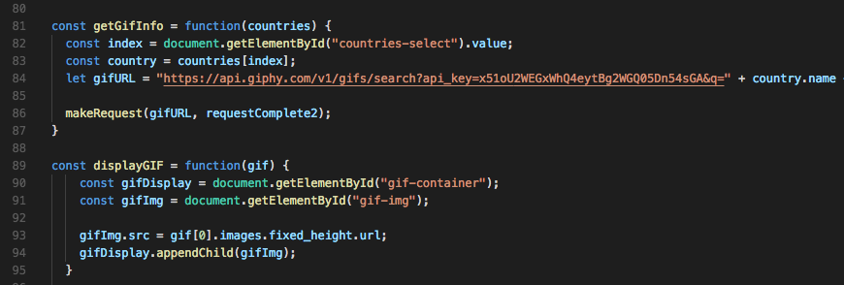

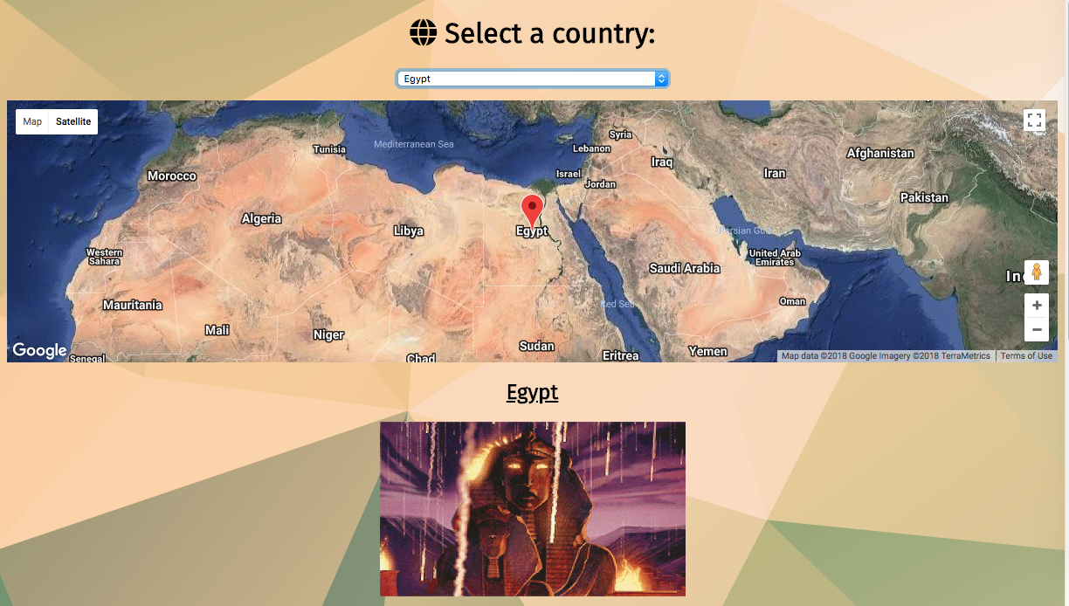

**P17 – Bug tracking report**

**P18 – Testing**

